Identifying Emotional States from Touch Gestures: A Minimalist Approach

Abstract
It is well known that affect and emotion plays an important role in human computer interaction. The challenge to an interactive system designer is to take the role of affect into account. In order to do that, it is necessary to detect the affective state of an individual during interaction. Touch input systems, particularly the smart phones and tabs, have become ubiquitous in recent years. Accordingly, mobile HCI is gaining importance. Our research is to detect user’s emotional state from their interaction on touch surfaces in devices like smart phones, without using any extra hardware, in a cost effective way. We propose to measure the affective state from 2D screen gestures, using the gesture size (in pixels) and the number of touch events as the only features. We propose a measure of arousal level, called the activity value (AV), determined from the gesture size over a period of interaction time. We propose to use AV and average touch events during a time interval along with the rate of change of AV across consecutive time intervals to determine the user’s emotional state, as one of the four states: high positive, high negative, low positive and low negative. High and low indicates the arousal level whereas positive and negative indicates the valence level. Empirical data shows high prediction accuracy for the proposed method. The method along with the empirical data collection and analysis are presented in this paper.

Keywords
Emotion, touch input, arousal and valence, activity value, degree of interaction.

- INTRODUCTION
Affective computing is the study and development of systems and devices that can recognize, interpret, process, and simulate human emotions and affects [27]. Affect being a very important human factor in our regular activities, a relevant application area of affective computing is the human-computer interaction (HCI). Systems that are responsive to human emotion are variously called as “polite”, “sympathetic”, “empathic” or simply “affective” [26]. All of these have the same aim: to improve usability and user experience by making the systems more natural and responsive to the goals and expectations of the user.
In order to design an affective interactive system, we first need to recognize the affective state of the user. This may be followed by the design of appropriate interaction and interface that complements and/or changes the user’s emotional state. In this research, we focus on the first step, namely the detection of the affective state of an interactive system user. Literature contains many works on emotion recognition. In these works, methods were proposed to recognize emotion from facial expression, gesture, posture and physiological signals. These mostly involved computer vision and image processing techniques, which are computationally expensive. In addition, such methods often require additional set ups such as cameras or probes and wires to record physiological signals.
In recent times, we are seeing an explosion of touch input systems all around us. They come in various shapes and sizes and include the smart phones, tabs and laptops. In fact, the desktop systems are also being made touch-enabled. According to some statistics, 59 million people were using smart phones till 2013 in India and it is expected to reach 265 million by 2016. The statistics is in fact reflective of a global trend. As a result, mobile HCI has become very important to improve usability of these devices. Affective touch interaction, which takes into account the affect and emotion of mobile touch screen users, has the potential to significantly improve usability of such devices. In this work, we focus on the first step towards achieving the objective; namely, detection of emotion for touch screen users.
Mobile devices have limited capacities in terms of their processor, storage and power back up. Moreover, the mobility aspect demands simplicity; the devices should not require too many extra attachments and wires. Consequently, most of the existing approaches are not suitable or feasible to detect mobile user’s emotional state. However, Studies have proven that distinct emotions can be interpreted from touch gestures [10, 13, 14, 30]. Therefore, an alternative approach is to predict affective state from the touch interaction behavior represented by the two-dimensional finger/touch gestures (finger strokes). The finger strokes are indirect cues to the affective state of a touch screen user.
The indirect cue based approach has a major advantage: we do not require additional sensors or wires to record the finger strokes. Also, the computations are much less compared to the other methods. Very few works are reported on this approach. We propose one such method in this work. However, we used only two touch interaction characteristic: the size of 2D touch gestures (in terms of pixels) and the number of touch events, to determine the emotional state. We have not found any work that can detect emotion from only two touch input features. Hence, our proposed approach provides a unique and novel method. Briefly, the idea is as follows.
We categorize users into four emotional states, namely high positive, high negative, low positive and low negative. The high and low indicates the arousal level whereas the positive and negative indicates the valence level. Arousal is the physiological state of being reactive to stimuli. It results in an observable change/action in the physical state of the body which causes us to become alert and ready to move and respond. In general, arousal is the level/amount of physical response. Valence is the intrinsic attractiveness or aversiveness of an emotion. In other words, it indicates whether or not people would want to feel something. For example, most people want to be happy and most people do not want to be sad; happiness is good, sadness is bad; happiness is positive, sadness is negative. In general, valence is the direction of the emotion. Given the finger strokes behavior of a user during touch interaction, we predict his/her affective state into one of these four categories. We use the size feature of the finger strokes, along with specific temporal intervals and the number of touch events, to determine the affective state. Our proposed model is derived and validated with empirical data. The proposed model along with the empirical data collection and analysis are described in this article. The article is organized as follows.
Works related to emotion detection are discussed in Section 2. The proposed approach is presented in detail in Sec 3. In this section, the touch gesture features we used as indirect cues for affective state detection is discussed, followed by the hypothesis which form the basis of the proposed approach. The hypothesis and the proposed approach were developed and validated with empirical data. The empirical study details are presented in Sec 4. Sec 5 presents the study results and analysis of the data. We propose an affective state detection algorithm AffectSense based on the analysis of the data, which is also included in Sec 5. Sec 6 discusses the pros and cons of the proposed approach along with the scope for future work. The article is concluded in Sec 7.
- RELATED WORK
Any work on emotion detection must start with some abstract representation of the human emotion. Literature contains two broad approaches to represent the emotional state of an individual [22]: discrete and dimensional representation.
In the discrete representation of emotion, it is assumed that emotions are discrete, measurable, and are physiologically distinct. According to this model, there are basic emotions such as happy, sad, angry, scared, tender and excited. Any emotional state can be considered to be a sub state of either of the basic emotional states [8]. As opposed to this, a two-dimensional coordinate system is used in the dimensional representation technique [28]. Emotions are plotted as points in this space where the x co-ordinate represents the valence level and the y co-ordinate represents the arousal level. Based on these two models, several works are reported on emotion detection.
Facial expressions are widely used to detect emotion (e.g., [3, 15, 18]). The works are mostly based on the theory proposed by Ekman et al [9]. The other common approach is to use body movements and postures as cues to emotional states. GEMEP (GEneva Multimodal Emotion Portrayals) [11] was developed as a mapping between the human upper-body movements to affective states. Bianchi-Berthouze and Kleinsmith [4] proposed an affective posture recognition system using an associative neural network. Emotion detection from full body movements was reported by Kapur et al [17] and Camurri et al [7]. Researchers worked to determine the affective states from physiological signals such as electrooculogram (EOG), galvanic skin response (GSR), heart rate (HR), electrocardiogram (ECG) and eye blinking rate (EBR) (e.g., [1, 12, 21, 32]). Soleymani et al [31] reported using eye gaze data for emotion detection.
The approaches mentioned above require significant computations. Many of those works also require extra setup including hardware such as video sensors, sensors to measure physiological signals, eye trackers and so on. The hardware is connected to the system through wires. As already stated before, our objective is to predict the affective state of touch screen users. We are mostly assuming small handheld devices such as the smart phones and tablets. These devices have limited computing powers. The additional setups may be costly and affect the affordability of such devices, one of the primary reasons of them being popular. Furthermore, the mobility of the devices may prevent the additional hardware to be attached to these devices. As a result, we need to come up with techniques that do not require extra set-up or significant computation.
It is already found out by researchers that distinct emotions can be communicated via touch [13, 14, 16, 20]. However, the studies were mostly conducted in the context of interpersonal communication. In the context of touch screen interaction, the user interacts with only the device. A related work investigated the possibility of conveying emotion through force feedback joystick [2]. Although the work involved human-device interaction, the emotions were still not natural. In contrast, we intend to predict emotion from natural behavior. Therefore, the works are not directly applicable to the problem we are trying to solve. However, these works clearly demonstrate that we can use the touch gesture information to detect the affective state of the user.
We are assuming here that touch provides an indirect cue to the emotional state. We surveyed the literature on works related to emotion detection from indirect cues and found very few that are relevant to our problem. Khanna and Sasikumar [19] have shown that emotion can be recognized by keystroke patterns, especially frequency of some special keys (e.g. spacebar and backspace). Epp et al [7] have also tried to identify emotional states using keystrokes dynamics. Lv et al [24] reported on a pressure sensor keyboard. Their objective was to investigate the role of pressure during key press to detect emotion. A high accuracy was reported following the approach. Matsuda et al. [25] investigated the role of finger movement characteristics, such as tap duration and acceleration, to predict the emotional state of Braille keyboard users. These works, however, were aimed to detect emotion for physical keyboard users. Touch-based interaction, on the other hand, is very different from keyboard-based interaction. Hence, these works are not relevant to our purpose. However, the works demonstrate that features such as pressure on a key or typing speed can be used to detect emotion.
All the above works are indirectly related to our objective. In contrast, Céline and Nadine [6] attempted to detect affective state from touch inputs. Clearly, the work fits our objective directly. However, they used both 2D screen gestures and 3D motion gestures. Apart from using a large feature set, the approach is constrained by its requirements of large amount of sensory inputs that may not be available with all smart phones, particularly the affordable ones. Gao et al [10] studied emotion detection from touch information on iPhoneTM, which is another directly relevant work. They also have used a large number of features as indirect cues and applied machine learning techniques to detect the affective state. Although the work is relevant, it relies heavily on a large amount of sensory input that may not be available in all devices. Shah et al [30] tried to overcome this limitation with a smaller set of features. However, some of these features, such as the deviations in the number of strokes and taps, may be difficult to know beforehand for use in automatic prediction.
In order to address the issues discussed above, we have developed a method that works based on just two features, namely the size of the touch gesture and the total number of touch events. Consequently, the method is expected to be easy to understand and implement. The method is presented in the following.
- PROPOSED APPROACH
In the proposed approach, we first estimate the arousal level of the user from the size feature of the touch interaction. This is done using the concept of activity value, which we propose for our work. Along with the size feature, we also make use of the number of touch events for the detection of arousal state. In order to obtain the valence level, we compare the activity values of the consecutive time intervals of touch interaction. The concepts and the detection process are explained in the following subsections.
  - The size Feature as the Indirect Cue
In general all touch screen devices have some commonalities. These devices usually have flat screens and the interactions performed on them are similar in nature. For example, to select a button, user clicks; to move to next page, user scrolls or swipes. We can classify touch interaction into broadly two types: 2D screen gestures and 3D motion gestures. 2D screen gesture are performed by directly making contact with the touch surface. The main 2D gestures are click, long click, swipe, scroll, and patting. 3D motion gestures, on the other hand, do not require screen contact. These gestures change the value of various sensors in the device, such as the proximity sensor, accelerometer sensor and light sensor. Though 3D motion gestures are not direct touch gestures on the screen, they provide “contextual information” about the user handling the device. Such information may be useful in affective state detection, as reported in the literature [6]. However, not all devices support all these sensors. Therefore, we are focusing on using 2D gestures only that are supported by all devices.
The 2D touch gestures have three common properties: the size, velocity and pressure. The size property indicates the number of pixels covered by the finger touch on the screen. The pressure applied on the screen during a touch gesture is captured by the pressure property. The velocity property records the velocity of the finger movement during swipe or scroll at a particular time.
As we know, velocity is the rate of change of size covered per unit time in a particular direction. Hence, it is directly proportional to the size. Finding pressure on the touch screen is hardware dependent. For most of the devices, the pressure value is represented with binary digits: 0 or 1 only. This is so since the devices lack the requisite hardware to represent real number values. Clearly, such binary values are not sufficient to get an idea of the difference in applied pressure during various instants of touch interaction. We can overcome this problem with a simple assumption: when the user applies more pressure on the flat screen, their fingers flattens out and cover more size on the screen. Based on this assumption, we can say pressure is directly proportional to size. We can therefore conclude that size is the atomic property from which other properties can be derived.
The size feature can be measured by using certain APIs provided by all the operating systems that come with the touch devices such as the AndroidTM or the WindowsTM. For example, the AndroidTM provides APIs like GestureDetector classes for sensing different gestures and measuring there size properties. Usually, the size property is measured in terms of pixels and the corresponding APIs return values within the normalized range of [0, 1], both inclusive. In this work, we assume the same, i.e., size is measured in terms of pixels and its values lies within the range [0, 1].
Since the size feature is fundamental in nature (i.e., other features are correlated to it) and universally measurable (i.e., it can be measured on all touch devices), we propose to use it as the main feature for affective state detection. In addition, we define another feature, degree of interaction (DoI). DoI is computed from the number of touch events during interaction. Both the size and DoI features are used together to predict the affective state of the touch user.

  - Choice of the Emotional States and the Working Hypotheses
In order to detect emotion, we propose to use discrete emotional states. In the literature, discrete representation of emotional states consists of states such as happy, sad, angry and so on. These states, being represented in natural languages, are easier to understand. However, their detection is difficult from a system’s perspective. This is because it is difficult to identify the appropriate feature set that captures the fine differences among these states. Consequently, the detection approach either becomes very complex or yield low accuracy.
In this work, we are using only two features. Therefore, traditional discrete states may not be suitable. We propose to use an alternative set of four discrete states based on the valence and arousal levels. The four states are as follows.
- High (arousal) positive (valence) state
- High (arousal) negative (valence) state
- Low (arousal) positive (valence) state
- Low (arousal) negative (valence) state
We based our idea of the four states on the Geneva Emotional Wheel (GEW) [29]. The GEW is a theoretically derived and empirically tested instrument, to measure emotional reactions to objects, events, and situations. The GEW contains 20 different emotion families with their intensities diverging out as shown in Fig. 1. The emotion families are arranged in a wheel shape with the axes being defined by the two major dimensions of emotional experience: valence (x-direction) and arousal (y-direction).
We propose to represent each of the four quadrants of the GEW as a distinct emotional state. Thus, the top-right quadrant is the high positive state, the top-left quadrant is the high negative state, the bottom-left quadrant is the low negative state and the bottom-right quadrant is the low positive state.
It has been reported that the user is likely to exert more pressure on the touch screen in a high arousal state [10] as the interaction is high and vice-versa. We have already assumed that size is directly correlated with pressure. Similarly, the DoI is also expected to be high in the high arousal state. These lead to the following working hypothesis.
Fig. 1. The Geneva Emotional Wheel (GEW) and our proposed partition f the wheel into four Abstract Emotional States.
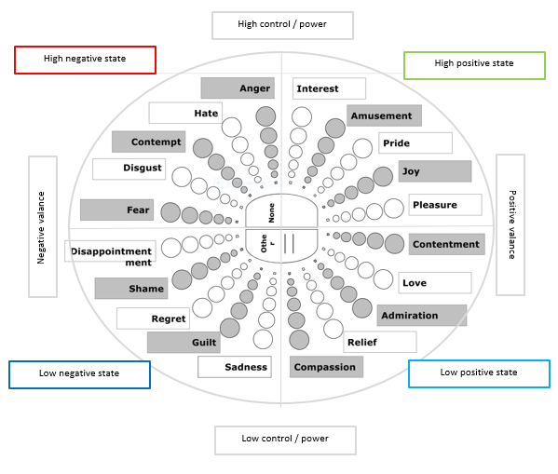

Hypothesis 1: The gesture size and DoI will be high in the high arousal level and low in the low arousal level.
With this hypothesis, we can differentiate between the high and low arousal levels. Along with that, we need the valence information to map a user into one of the four emotional states. We propose to obtain the information by considering the change of arousal levels over a period of time, with the following hypothesis.
Hypothesis 2: In the negative state, the rate of change of arousal level will be high. The rate of change will be low in the positive state.
Hypothesis 2 is basically another way of saying that the negative state (e.g., frustrated) sustains less long than the positive state (e.g., excited), as our intuition and observations confirm. We can use hypotheses 1 and 2 together to determine the affective state of a user with the following set of rules.
- High positive state: the arousal level is high but the rate of change in arousal level is low.
- High negative state: the arousal level is high and the rate of change in arousal level is also high.
- Low positive state: the arousal level as well as its rate of change is low.
- Low negative state: the arousal level is low but the rate of change in arousal level is high.
Although the rules provide us with the means to determine the affective state, the description so far has been mostly qualitative. It is not possible to come up with a system for automatic detection of the affective state unless we quantify the high and low values. In order to do that, we propose the concept of activity value, as discussed next.
  - Measuring Valence and Arousal with Activity Value
Emotion, as we know, is not instantaneous; once it happens, an individual remains in that state for some time. As a result, we should measure it over a period of time rather than at any time instance. We propose to follow this idea for measuring both the valence and arousal levels.
We propose to capture the arousal level of a touch screen user based on his/her interactions (touch gestures) over a time interval τ. Let there be n number of touch gestures that have taken place during that interval. For each of these gestures, we determine the size value s_{i}. We then add up these values over the period τ. We call this quantity the activity value (AV). Thus,
Activity value (AV) = 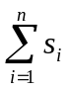 …………………. (1)
During the touch interaction, each touch gesture made by the user generates a touch event. We capture the number of touch events during the time interval τ. This number represents the DoI feature value. We propose to use AV and DoI as the measure of arousal. Depending on these values, we decide if the arousal level is high or low.
The valence level is determined by the rate of change of arousal level. Suppose there are two consecutive time intervals τ_{i} and τ_{i+1}, with the corresponding activity values AV_{i} and AV_{i+1}. The rate of change of AV per unit interval (δAV) is the absolute difference of the two AVs, as shown in Eq 2.
δAV (Rate of Change of AV) = |AV_{i+1} - AV_{i}| …………….. (2)
Depending on the value of δAV, we decide if the rate of change of arousal value is high or low and accordingly decide on the valence level on the basis of hypothesis 2.
It may be noted that the proposed method for affective state detection depends on two hypothesis as well as two fuzzy quantities: high and low. We performed empirical studies to validate the two hypotheses and quantify “high” and “low”. The details of the empirical study are described next.
- DETAILS OF EMPIRICAL STUDY
  - Experimental Setup
In order to collect emotional data of touch screen users, we designed a game app: HackEmo for Android OS. In this game, the player gets to see a number first which is displayed on the screen. There are five “buckets” denoted by the letters A – E. The number is put into one of these buckets. The player has to guess the bucket in which the number is put (by clicking on the right bucket on the screen). The game duration is of 60 seconds. Each wrong guess attracts a penalty. The game interface is shown in Fig 2.
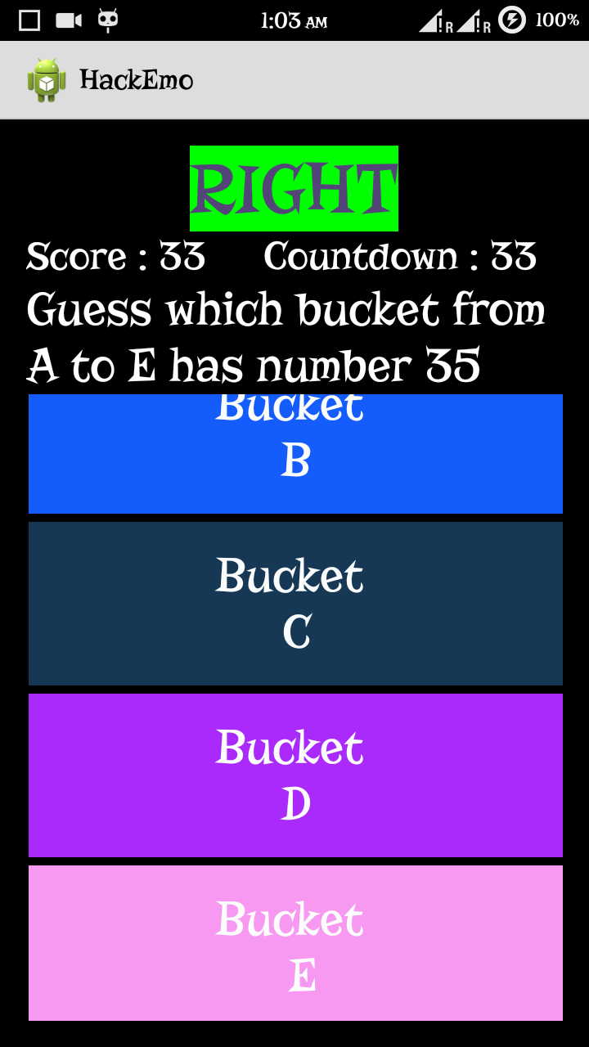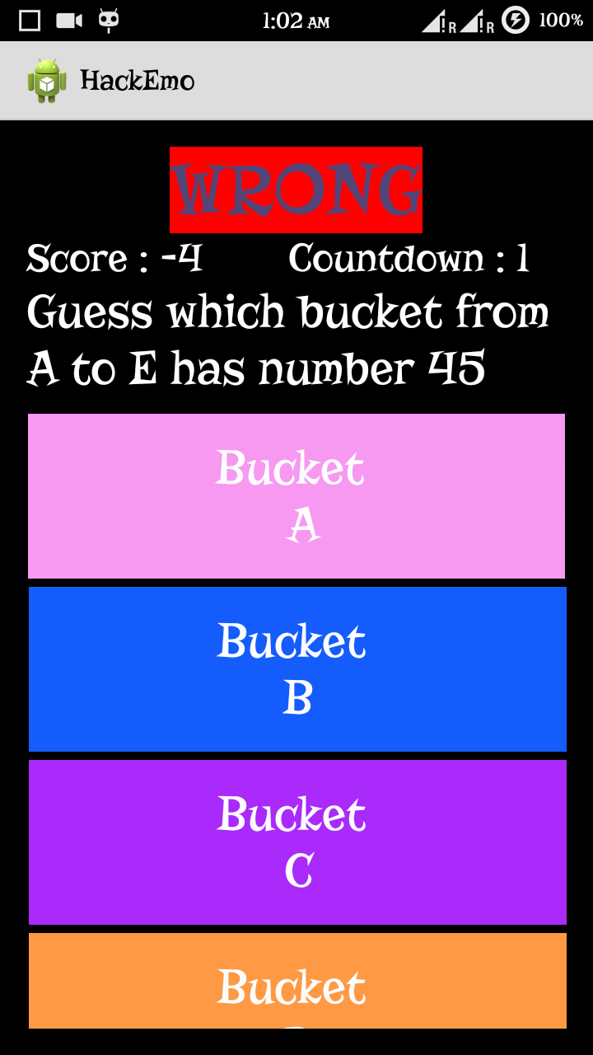
Fig. 2. The HackEmo game interface with two possible situations.
The game has the following three modes. However, the players were not informed about these modes.
- Winning mode: in this mode, the player always wins.
- Losing mode: in this mode, the player always loose.
- Random mode: the player has 50% probability of winning or losing.
The game duration of 60 seconds was divided into four segments of 15 seconds each. The random mode was placed in the interval of 0-15 seconds and 31-45 seconds (from start). The other two modes (winning and losing) were randomly placed in the time intervals between 16-30 secs and 46-60 secs (from start) for each new instance of game play. The random mode was included to minimize the effect of any bias in the data before the start of the winning or losing mode. The game design strategy is summarized in Table 1.
The data were collected with two smart phones: an HTC desire 816TM running on Android 4.4.2 and a Micromax Yu Yureka AO5510TM running on Cyanogen based OS 11. Both the devices had the same screen size (5.5 inch) and resolution (720x1280 pixels); hence same PPI (pixels per inch) of 267.
All the touch gestures of the participants were recorded by the app during the game plays.
Mode | Time interval (sec) – from start of the game
Random | 0-15 & 31-45
Losing, Winning | Alternative 16-30 or 46-60
Table 1. The strategy adopted to design the HackEmo game.
  - Participants
We collected data from 16 volunteers. Ten of them were males and six females. They were within the age group of 19-25 yrs, with the average age of 20.56 yrs. All of them were regular users of touch devices, including both tabs and smart phones.
  - Procedure
The data collection process consisted of two phases: training phase followed by collection of data. During the training phase, the game was explained to the participants, including the rule that wrong guess attracts penalty. Then, the game was demonstrated to the participants. Subsequently, they were asked to play the games themselves. The participants were instructed to get as much score as possible. Each of them was asked to play two games, one on each device, resulting in a total of 16×2 = 32 gameplays.
- RESULTS AND ANALYSIS
It may be recalled that we propose to measure the activity value over a time interval. We assumed a 3 sec time interval for data analysis (i.e. τ = 3 sec). Choice of an appropriate time interval is not easy and we should keep in mind the way individuals react to stimuli. For example, emotional reaction to a text message may be dependent on a series of events and activities: getting a notification about the message, followed by reading the sender’s name and figuring out the sender’s identity (e.g., whether from boss or friend), followed by reading of the text. The affective state at the end of all these activities may depend on all of them. Thus, the particular state is arrived at after some seconds that was spent for all these activities. While trying to determine the affective state, we should consider this entire duration. We assume 3 sec to be an appropriate duration to capture all the actions/events in any touch interaction in general and the game play scenario in particular that affects the emotional state of a user.
During the game play by the participants, the following information were recorded by the system.
- Activity value (AV)
- Rate of change in activity value (δAV)
- Total touch gestures
The last item (total touch gestures) is an important indicator for the arousal level (low/high). It is expected that a player is likely to make more touch gestures in a high arousal state as compared to a low arousal state. We analyzed the total touch gesture values for each game play. It varied from as low as about 150 to as high as about 800. Interestingly, we observed that for 16 of the 32 gameplays, total touch gesture value was less than 500. For each of the remaining game plays, it was more than 500. On the basis of this observation, we divided the dataset of 32 gameplays into the following two groups.
- Low arousal dataset: 16 gameplay data belonged to this group. For each of these gameplays, the total touch gesture value was less than 500.
- High arousal dataset: the dataset consisted of the remaining 16 gameplay data. For each of these gameplays, the total touch gesture value was more than 500.
It may be reasonably assumed that a player is likely to be in a positive state of mind during the winning mode of the game. Similarly, the player is likely to be in a negative state during the losing mode. Based on these assumptions, we extracted the game play data (AV and δAV) during the winning and losing mode for each game. Subsequently, the values were normalized. Thus, for each game play, we had 4 data items: mean AV and δAV of all the players during the winning and losing modes, resulting in a total of 32×2 = 64 AV values and 32×2 = 64 δAV values. In addition, there were 32 DoI values (one for each gameplay). In order to develop the proposed approach and test it, we divided the data into two groups: training data set and test data set. About 80% of the data items collected were used in the training set. The remaining 20% data items were used to test the approach.

  - AV Data Analysis
Out of the 64 data items for AV, we considered 48 (about 80%) for analysis. The rest were used as test data. The training data were divided into two groups: high arousal (gameplay data in which total touch events were more than 500) and low arousal (gameplay data in which total touch events were less than 500). Each group contained 24 data items. We plotted the data items against players. Which are shown in Fig 3(a) (high arousal) and 3(b) (low arousal).
Figure 3 shows that there is not much difference between the distribution of the data points in the winning and losing modes in both the plots. This indicates that the mode does not affect the arousal level. However, it may be noted from Fig 3 that the average AVs in the low arousal state were mostly less compared to the corresponding values in the high arousal state. The values indicate partial validity of hypothesis 1, namely the touch gesture size (activity value) is high in the high arousal state and low in the low arousal state.
In the high arousal level (Fig 3a), most of the data points (22 out of 24 or about 92%) are equal or greater than 0.3. In other words, the high arousal state is characterized by AV greater than or equals to 0.3. Similar trend is visible in the low arousal state (Fig 3b). The data points are mostly equal or lower than 0.55 (20 out of 24 or about 83%). Therefore, we may infer that the low arousal state is characterized by AV less than or equal to 0.5. The relationship between AV and the arousal level is summarized in Table 2.
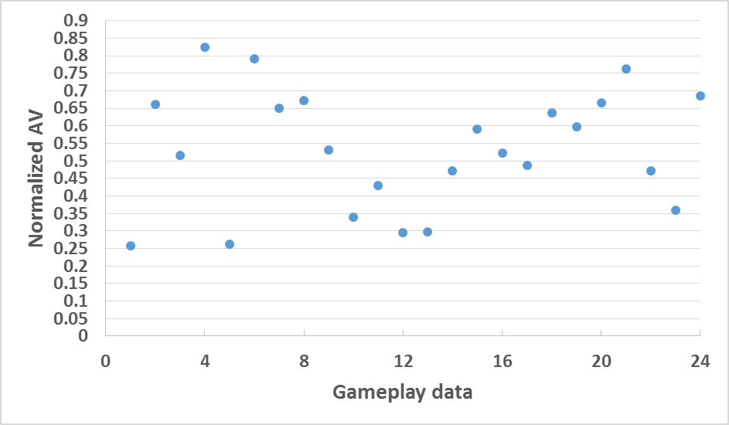
Winning mode
Losing mode
- AV variation in high arousal state
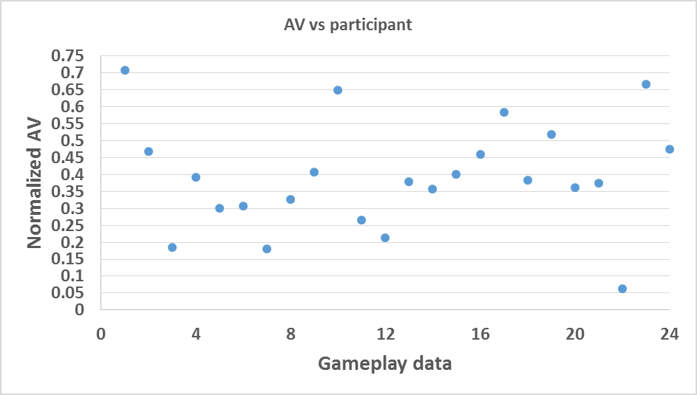
Winning mode
Losing mode
- AV variation in low arousal state
Fig 3. The variation in AV. The vertical line in the middle of each graph separates the winning mode and the losing mode data.
Arousal Level | High | Low
Mapping to AV | AV ≥ 0.3 | AV ≤ 0.5
Table 2. Relationship between arousal level and AV.
5.2 Analysis of the DoI Data
In Table 2, it may be noticed that there is an element of ambiguity when the AV lies between 0.3 and 0.5. In that case, it is not possible to predict the arousal state (high or low) unambiguously. In order to resolve this issue, we studied the degree of interaction (DoI). The DoIs were measured only for the active intervals in a game play, i.e., only for those intervals in which touch events took place. We computed the DoIs for each gameplay as follows.
DoI = total number of touch events/total number of active intervals
Fig 4 shows the plot for the DoI for both the high and low arousal states for the 24 gameplays in the training set. In the plot, each point represents the normalized DoI of a player in a gameplay.
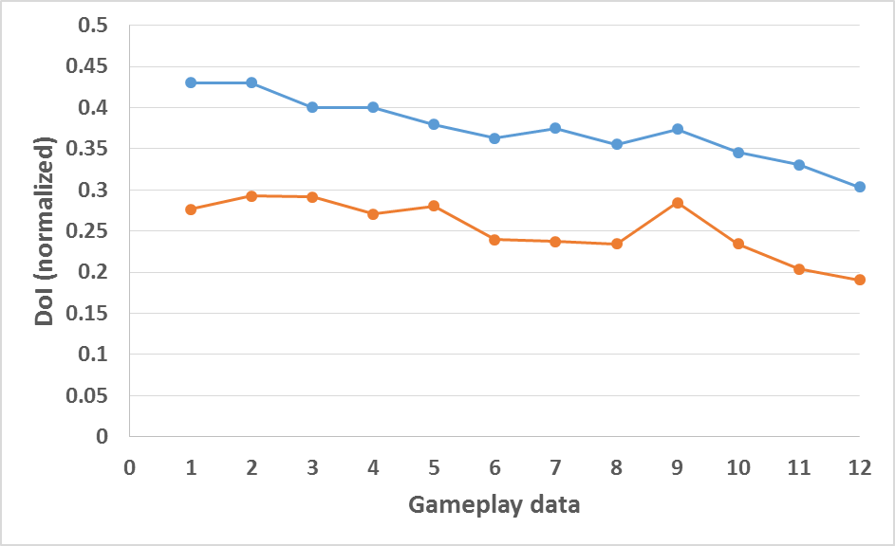
High arousal state
Low arousal state
Fig 4. The variation of DoI in the two arousal states.
As Fig 4 illustrates, a clear distinction is visible between the DoIs of the low and high arousal states. For the high arousal state, the DoIs are greater than or equal to 0.3. For the low arousal state, the DoI values are less than 0.3. The observation supports the other part of hypothesis 1, namely the DoI is high in the high arousal state and low in the low arousal state. Based on these observations and also taking into account Table 2, we propose the following (Table 3) mapping of the AV and DoI values to arousal state.
AV | AV < 0.3 | 0.3 ≤ AV ≤ 0.5 |  | AV > 0.5
AV | AV < 0.3 | DoI < 0.3 | DoI ≥ 0.3
Arousal Level | Low | Low | High | High
Table 3. Relationship between arousal level, AV and DoI.
  - Analysis of δAV Data
As with the AV data, we also plotted the normalized mean δAV data against the players. About 80% of all the data items (48 out of 64) were used in the training set; the rest of the data were used for testing. We plotted the data separately for the high and low arousal state, as was the case with the AV data. The plots are shown in Fig 5(a) (high arousal) and 5(b) (low arousal).
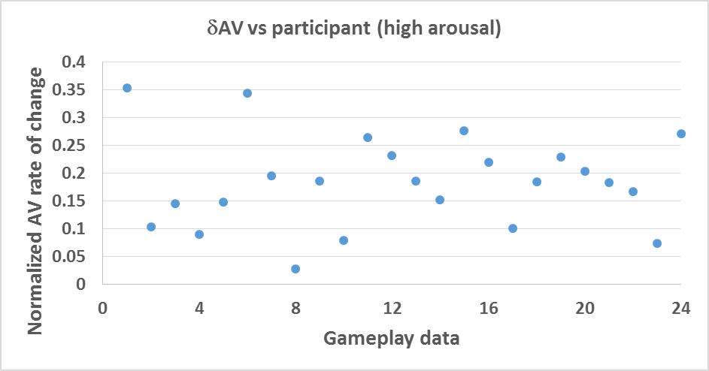
Winning mode
Losing mode
- Variation in δAV in the high arousal state
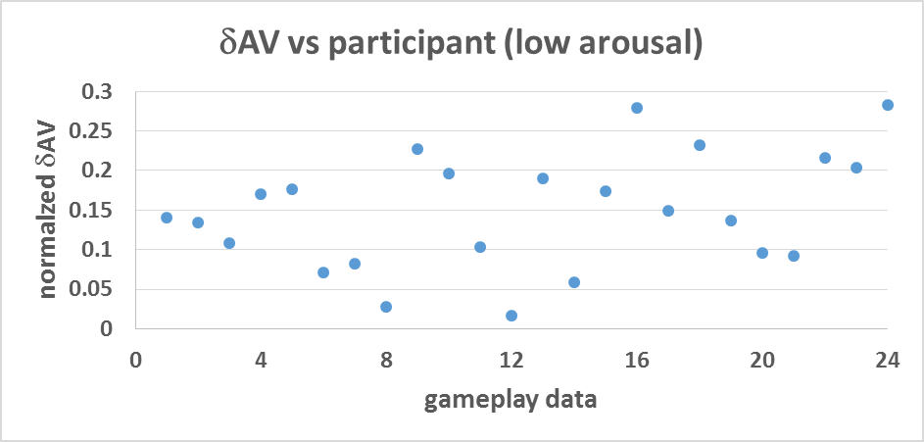
Losing mode
Winning mode
- Variation in δAV in the low arousal state
Fig 5. The variation in δAV. The vertical line in the middle of each graph separates the winning mode and the losing mode data.
As Fig 5 clearly shows, δAV is mostly higher in the losing mode than the winning mode in both the high and low arousal states. The results, therefore, indicates the validity of hypothesis 2.
In both Fig 5(a) and 5(b), it can be observed that the spread of the δAV values are not much different between the low and high arousal states. Thus, the arousal level is not influencing the δAV. However, difference is clearly visible between the winning (positive valence) and losing (negative valence) modes. The δAV values are mostly less than or equals to 0.15 in the winning mode (14 out of 24 data items considering both the arousal levels or about 60%). Similarly, the δAV values in the losing mode are mostly greater than 0.15 (18 out of 24 data items considering both the arousal levels or about 75%). Based on these observations, we propose the following mapping (Table 4) between the valence level (positive/negative) and the rate of change in AV.
Valence Level | Positive | Negative
Mapping to δAV | δAV ≤ 0.15 | δAV > 0.15
Table 4. Relationship between valence level and δAV.
  - Mapping of AV, δAV and DoI to Affective State
Based on Table 3 and 4, we propose a mapping between the four emotional states and the activity values, which is shown in Table 5.
Emotional State | Activity value characteristics
High Positive | [AV > 0.5, δAV ≤ 0.15] OR [0.3 ≤ AV < 0.5, DoI ≥ 0.3, δAV ≤ 0.15]
High Negative | [AV > 0.5, δAV > 0.15] OR [0.3 ≤ AV < 0.5, DoI ≥ 0.3, δAV > 0.15]
Low Positive | [AV < 0.3, δAV ≤ 0.15] OR [0.3 ≤ AV < 0.5, DoI < 0.3, δAV ≤ 0.15]
Low Negative | [AV < 0.3, δAV > 0.15] OR [0.3 ≤ AV < 0.5, DoI < 0.3, δAV > 0.15]
Table 5. Proposed mapping of the activity value and its rate of change to emotional states.
We use Table 5 to detect the affective state of a touch screen user. For this purpose, we propose an algorithm SenseAffect, whose steps are shown in Table 6. In a touch screen device, the algorithm should run in the background continuously (the infinite loop in line 4). After every interval (of duration τ sec), it returns the affective state as one of the four states (by setting a global/environment variable, which can be used by other apps).
ALGORITHM SenseAffect ()
- AState = Low Negative; /*the global state variable, initialized to low negative state*/
- Int i = 1; /* Index for time interval. Each interval is of duration τ sec*/
- Float AV = 0.0, DoI = 0.0; /* Initialize the activity and DoI values*/
- WHILE (TRUE){
  - Determine normalized AV for the τ_{i} time interval (AV_{i});
  - Determine DoI = normalized(no of touch events) for the interval;
  - Compute δAV: AV_{i} – AV;
/* Table lookup – Table 5 */
  - IF [(AV > 0.5) AND (δAV ≤ 0.15)] OR [(0.3 ≤ AV ≤ 0.5) AND (DoI ≥ 0.3) AND (δAV ≤ 0.15)]
AState = High Positive;
IF [(AV> 0.5) AND (δAV > 0.15)] OR [(0.3 ≤ AV ≤ 0.5) AND (DoI ≥ 0.3) AND (δAV > 0.15)]
AState = High Negative;
IF [(AV < 0.5) AND (δAV ≤ 0.15)] OR [(0.3 ≤ AV ≤ 0.5) AND (DoI < 0.3) AND (δAV ≤ 0.15)]
AState = Low Positive;
IF [(AV< 0.5) AND (δAV > 0.15)] OR [(0.3 ≤ AV ≤ 0.5) AND (DoI < 0.3) AND (δAV > 0.15)]
AState = Low Negative;
  - Update AV: AV = AV_{i};
  - Update i: i++;
}
Table 6. The steps of the proposed affective state detection algorithm SenseAffect.
- DISCUSSION
We tested the proposed algorithm on the test set consisting of the 16 game play data, in order to ascertain its validity. We labeled each test set data element with one of the four states: high positive, high negative, low positive and low negative. The high and low arousal value was decided based on the number of touch events, as mentioned before (Sec 5.1). The winning mode was assumed to represent the positive valence whereas the losing mode was considered to be negative valence.
Next, we applied the SenseAffect algorithm on each test data element to predict the affective state. We matched the states returned by the algorithm to that of the known states. The results are shown in Table 7.
Data item | N | Mode | AS (known) | AV | DoI | δAV | AS (predicted) | Match
1 | 530 | Win | High Positive | 0.51 | 0.33 | 0.34 | High Negative | No
2 | 515 | Win | High Positive | 0.41 | 0.27 | 0.03 | Low Positive | No
3 | 505 | Win | High Positive | 0.89 | 0.3 | 0.14 | High Positive | Yes
4 | 794 | Win | High Positive | 0.34 | 0.53 | 0.35 | High Negative | No
5 | 530 | Lose | High Negative | 0.43 | 0.33 | 0.18 | High Negative | Yes
6 | 515 | Lose | High Negative | 0.51 | 0.27 | 0.2 | High Negative | Yes
7 | 505 | Lose | High Negative | 0.38 | 0.3 | 0.16 | High Negative | Yes
8 | 562 | Lose | High Negative | 0.42 | 0.33 | 0.18 | High Negative | Yes
9 | 296 | Win | Low Positive | 0.21 | 0.23 | 0.04 | Low Positive | Yes
10 | 215 | Win | Low Positive | 0.13 | 0.14 | 0.13 | Low Positive | Yes
11 | 143 | Win | Low Positive | 0.2 | 0.12 | 0.18 | Low Negative | No
12 | 457 | Win | Low Positive | 0.49 | 0.25 | 0.06 | Low Positive | Yes
13 | 296 | Lose | Low Negative | 0.36 | 0.23 | 0.12 | Low Positive | No
14 | 215 | Lose | Low Negative | 0.17 | 0.16 | 0.14 | Low Negative | Yes
15 | 143 | Lose | Low Negative | 0.16 | 0.12 | 0.07 | Low Positive | No
16 | 343 | Lose | Low Negative | 0.44 | 0.19 | 0.16 | Low Negative | Yes
Table 7. Validation results for the proposed approach. N is total number of touch events; AS denotes affective state.
Overall, the proposed algorithm could accurately predict 10 out of 16 cases, with an accuracy of 62.5%. However, Table 7 demonstrates some interesting statistics about the strength and weakness of the proposed algorithm. Out of the 16 cases, the algorithm was able to accurately predict the arousal level in 15 instances, with an accuracy of about 95%. On the other hand, the prediction accuracy for the valence state (positive/negative) was lower; 11 out of 16 cases or about 61%. Out of the 8 cases with positive valence, the algorithm predicted the right valence in 5 cases (63%). Among those 5, 2 were in the high arousal state and 3 in the low arousal state. In other words, the prediction accuracy of positive valence in the high arousal state was moderate (50%), whereas the algorithm performed much better in the low arousal state to predict the positive valence (75%). For the negative valence, the prediction accuracy was much higher (6 out of 8 or 75%). Among those 6, 4 were in the high arousal state; thus achieving an accuracy of 100%. The remaining 2 were in the low arousal state, with an accuracy of 50%. From these observations, we can come to the following conclusions.
- The proposed algorithm can predict with very high accuracy (≈95%) the arousal level from the touch input data.
- In the high arousal state, the algorithm can predict the negative valence state with very high accuracy (nearly 100%). However, accuracy for detection of positive valence may be moderate (near about 50%).
- In the low arousal state, the prediction accuracy for positive valence is high (75%). However, the negative valence may be detected with moderate accuracy (50%).
We believe the proposed algorithm is unique and novel in the sense that it uses only two features to detect emotion. As a result, it is very simple to understand and implement. Moreover, it does not require any additional setup. By relying on features that can be measured in any device, it provides a universally implementable algorithm. We can use the proposed algorithm as follows. It can be implemented as an app that runs in the background. It keeps on monitoring all the touch gestures and captures their size feature during the specified 3 sec interval. With those values in the consecutive intervals, it computes the affective state and sets a global state variable. Once we are able to detect user’s emotional state from his/her interaction with the device, we can use the information to change the look and feel of the interface, to complement the emotional state. We can also make changes in the way tasks are performed depending on the current state of user emotion. This may lead to “polite” interfaces, which are “empathic”. Such qualities, in turn, are expected to improve usability and enhance user experience. We intend to work on the use of the affective state information for the interface and interaction design in future.
Note that the algorithm considers two consecutive time intervals to predict the valence level. Instead of two intervals, can we predict with higher accuracy if the number of consecutive intervals to be compared is taken as three? Or four? We feel any increase in the number of consecutive intervals to be compared will not change the prediction accuracy much. This is so since the difference pattern (large or small) can be captured within the consecutive time intervals. Another important aspect of the algorithm is the interval size. Here, we assume that the 3 sec interval is suitable to capture the affective state of touch input users. The touch actions that take place within this time period can point to the arousal level. The high prediction accuracy of the arousal level, as indicated in the validation study supports this choice. We may reasonably assume that larger interval size may not be required. However, should we consider any smaller size? We feel choosing a smaller interval size may be detrimental since that may affect the DoI and δAV, which in turn may lead to lower prediction accuracy of the affective state.
An important aspect of the approach is the choice of two features (AV and DoI), for the prediction of the arousal level but not the valence level. For arousal level prediction, only one feature was not sufficient and often led to ambiguities (see for example Fig 3 and the data in row number 5, 7, 8, 12 and 16 in Table 6). If we consider either one of them, the prediction accuracy falls drastically. On the other hand, not much difference was observed in the DoI values between the winning and losing modes in a particular arousal state. Hence, we did not consider DoI for the prediction of valence level.
Our approach relies on a discrete representation of emotion. We assumed four emotional states of a touch screen user. However, there is a difference between the discrete states mentioned in the literature (e.g., happy, sad, excited etc) and the states we propose. We deliberately decided to go for the proposed states since it is difficult to predict with high accuracy the affective states such as happy and sad, at least for touch input users, as reported in [10]. However, high accuracy in prediction is possible if we go for discretization of the dimensional representation [10]. We believe that the dimensional information communicated through the proposed discretization is equally or more suitable for further use in touch interaction design than provided by the traditional discrete states.
We designed the algorithm (Table 5) from empirical data. The accuracy was also estimated from a relatively small data set. We feel more data may result in more accurate estimation of these data values and higher accuracy figure. Hence, we plan to perform more studies in future to refine these values.
- CONSLUSION
In this paper, we proposed an algorithm for the detection of the affective state of touch screen users. The algorithm works based on two touch input features: size of the touch gesture (in pixels) and the number of touch events. We introduce the novel concept of activity value and degree of interaction as estimators of the arousal level. These are computed over a time period. Comparison of consecutive activity values indicate valence level. Together, these are used to predict the affective state of a touch input user as one of the four states: high positive, high negative, low positive and low negative. Empirical data demonstrates that the proposed algorithm can be used to predict the affective state with reasonably high accuracy. In future, we plan to collect more data to refine and validate the model. In addition, we also intend to work on the design of affective touch interaction, based on the estimated affective state.
REFERENCES
- AlZoubi, O., D'Mello, S. and Calvo, R. Detecting Naturalistic Expressions of Nonbasic Affect using Physiological Signals. IEEE Transactions on Affective Computing, 3(3), 298-310, 2012.
- Bailenson, N.J., Brave, N.Y.S, Merget, D., and Koslow, D. Virtual interpersonal touch: expressing and recognizing emotions through haptic devices. Human-Computer Interaction, 22, 325–353, 2007.
- Bartneck, C. and Reichenbach, J. Subtle Emotional Expressions of Synthetic Characters. International Journal of Human-Computer Studies, 62, 179-192, 2005.
- Bianchi-Berthouze, N. and Kleinsmith, A. A categorical Approach to Affective Gesture Recognition. Connection Science, 15(4), 259-269, 2003.
- Camurri, A., Lagerlof, I. and Volpe, G. Recognizing Emotion from Dance Movement: Comparison of Spectator Recognition and Automated Techniques. International Journal of Human-Computer Studies, 59(1), 213-225, 2003.
- Céline C. and Nadine M. Identifying emotions expressed by mobile users through 2D surface and 3D motion gestures. Proc. 2012 ACM Conference on Ubiquitous Computing (UbiComp 12), pp 311-320, 2012.
- Epp, C., Lippold, M., Mandryk, R.L. Identifying Emotional States using Keystroke Dynamics. In Proc. CHI2011, ACM Press (2011), 715-724.
- Ekman, P. An Argument for Basic Emotions. Cognition and Emotion, 6 (3/4), 1992.
- Ekman, P., Sorenson, E. R. and Friesen, W. V. Pan-cultural Elements in Facial Displays of Emotion. Science, 164(3875), 86-88, 1969.
- Gao, Y., Bianchi-Berthouze, N. and Meng, H. What Does Touch Tell Us about Emotions in Touchscreen-based Gameplay? ACM Transactions on Computer-Human Interaction (TOCHI), 19(4), 2012.
- Glowinski, D., Dael, N., Camurri, A., Volpe, G., Mortillaro, M., and Scherer, K. Toward a Minimal Representation of Affective Gestures. IEEE Transactions on Affective Computing, 2(2), 106-118, 2011.
- Hazlett, R.L. Measuring Emotional Valence during Interactive Experiences: Boys at Video game play. In Proc. CHI2006. ACM Press (2006), 1023-1026.
- Hertenstein, M. J., Holmes, R., Mccullough, M., and Keltner, D. The Communication of Emotion via Touch. Emotion, 9, 4, 566-573, 2009.
- Hertenstein, M. J., Keltner, D. App, B. Bulleit, B. A. and Jaskolka, A. R. Touch communicates distinct emotions. Emotion, Vol 6(3), 528-533, 2006.
- Isbister, K., Hook, K., Sharp, M. and Laaksolahti, J. The Sensual Evaluation Instrument: Developing an Affective Evaluation Tool. In Proc CHI 2006, 1163-1172. ACM, 2006.
- Jones, S.E., and Yarbrough, A.E. A naturalistic study of the meanings of touch. Communication Monographs, 52, 19-56, 1985.
- Kapur, A., Kapur, A., Virji-Babul, N., Tzanetakis, G. and Driessen, P. F. Gesture-based Affective Computing on Motion Capture Data. Affective Computing and Intelligent Interaction, LNCS 3784, 1-7, Springer, 2005.
- Katsyri, J. and Sams, M. The Effect of Dynamics on Identifying Basic Emotions from Synthetic and Natural Faces. International Journal of Human-Computer Studies, 66(4), 233-242, 2008.
- Khanna, P. and Sasikumar, M. Recognising Emotions from Keyboard Stroke Pattern. International Journal of Computer Applications, 11(9), 2010.
- Knapp, M.L., and Hall, J.A. Nonverbal communication in human interaction (4th ed.). Harcourt Brace College Publishers, 1997.
- Koelstra, S., Yazdani, A., Soleymani, M., Muhl, C., Lee, J., Nijholt, A., Pun, T., Ebrahimi, T. and Patras, I. Single Trial Classification of EEG and Peripheral Physiological Signals for Recognition of Emotions Induced by Music Videos. Brain informatics, pages 89-100. Springer, 2010.
- Lichtenstein, A., Oehme, A., Kupschick, S. and Jurgensohn, T. Comparing Two Emotion Models for Deriving Affective States from Physiological Data. Peter, C and Beale, R. (eds). Affect and Emotion in Human Computer Interaction: From Theory to Application. LNCS 4868, 35-50, Springer, 2008.
- Lottridge, D., Chignell, M. and Jovicic, A. Affective Interaction: Understanding, Evaluating, and Designing for Human Emotion. Human Factors and Ergonomics,7(1),197-217, 2011.
- Lv, H., Lin, Z., Yin, W., and Dong, J. Emotion recognition based on pressure sensor keyboards. IEEE International Conference on Multimedia and Expo, 1089-1092, 2008.
- Matsuda, Y., Sakuma, I., Jimbo, Y., Kobayashi, E., Arafune, T., and Isomura, T. Emotion recognition of finger Braille. International Journal of Innovative Computing, Information and Control, 6, 3(B), 1363-1377, 2010.
- Peter, C and Beale, R. (eds). Affect and Emotion in Human Computer Interaction: From Theory to Application. LNCS 4868, Springer, 2008.
- Piccard, R. W. Affective Computing. MIT Press, Cambridge, 1997.
- Russell, J. A. A Circumplex Model of Affect. Journal of Personality and Social Psychology,39(6), 1161-1178, 1980.
- Sacharin, V., Schlegel, K., and Scherer, K. R. Geneva Emotion Wheel rating study (Report). Geneva, Switzerland: University of Geneva, Swiss Center for Affective Sciences, 2012.
- Shah, S., Teja, J. N. & Bhattacharya, S. (2015). Towards Affective Touch Interaction. Predicting Mobile User Emotion from Finger Strokes. Journal of Interaction Science (JoIS), 3(1), pp 1-15.
- Soleymani, M., Pantic, M. and Pun, T. Multimodal Emotion Recognition in Response to Videos. IEEE Transactions on Affective Computing, 3(2), 211-223, 2012.
- Takahashi, K. Remarks on Emotion Recognition from Bio-Potential Signals. In Proc. Second Int‘l Conf. Autonomous Robots and Agents, (2004), 186-191.

The Economic times, May 2012.
Available in GitHub, http://github.com/jimmy17x/HackEmo

